Day 1:

Topic: GIT- version control system.

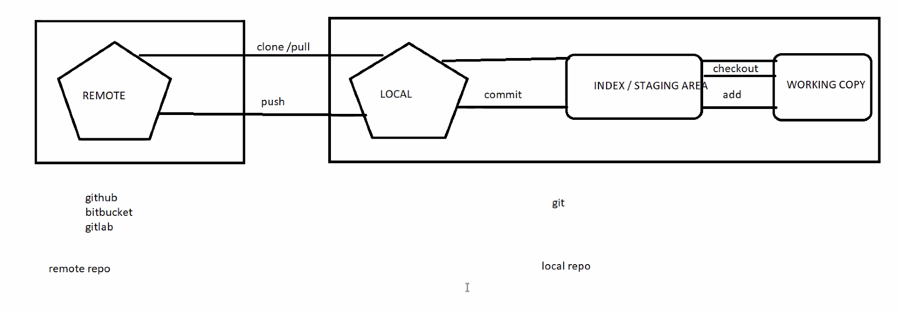

Location of git on local:

